Fish abundance (all species including sea turtles)

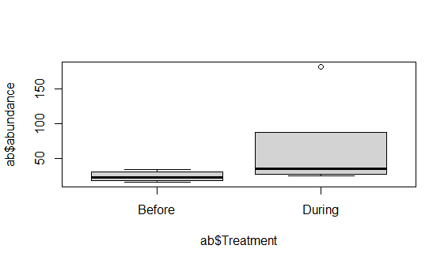

Coefficients:

Estimate Std. Error t value Pr(>|t|)

(Intercept) 3.2243 0.3161 10.199 7.33e-06 \*\*\*

TreatmentDuring 0.7009 0.4081 1.717 0.124

Groupers and snappers abundance only

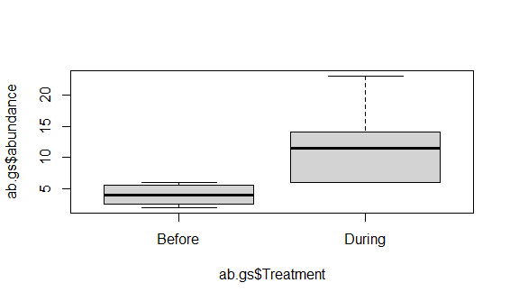

Coefficients:

Estimate Std. Error t value Pr(>|t|)

(Intercept) 1.5556 0.2227 6.986 0.000114 \*\*\*

TreatmentDuring 0.9135 0.2875 3.178 0.013043 \*

Sea turtle abundance only

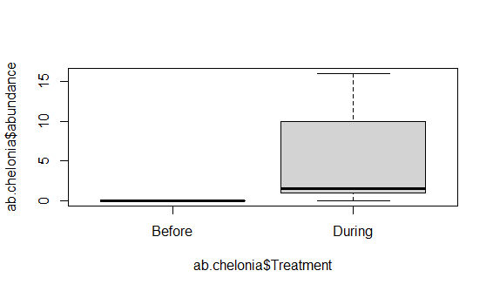

Coefficients:

Estimate Std. Error t value Pr(>|t|)

(Intercept) 0.0000 0.4338 0.000 1.0000

TreatmentDuring 1.2860 0.5600 2.296 0.0508 .